# Topics

* Programming functions
* Formatted output sprint()
* Ggplot2
* Simulation and Program Design

# Programming functions

* Functions are only executed when called
* PC labs: handy if you use separate files
  + - Save 1 function to 1 file
    - Source(file)

# Formatted output

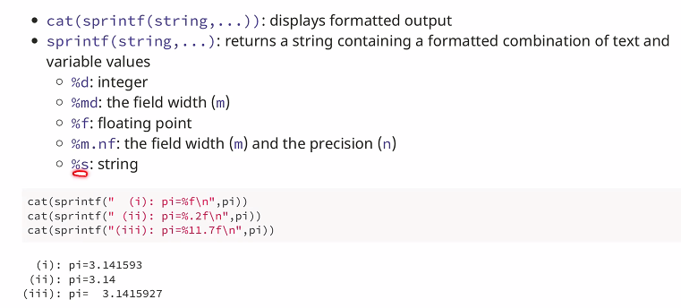

*Example:*

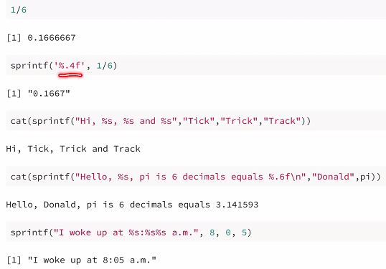

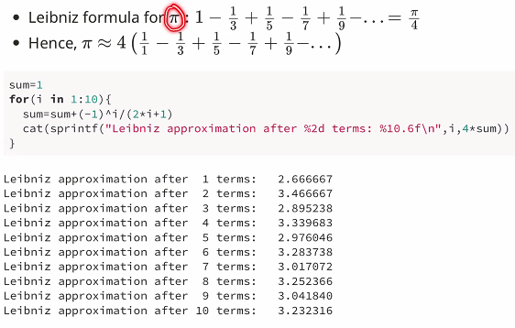

# Ggplot2 package

* Build graph by layers

# Elements of grammar of graphics

1. Data
2. Geoms – objects/shapes on graph
3. Stats – mean, conf. intervals, etc.
4. Scales
5. Coordinate systems
6. Faceting (paneling)

# Ggplot() function

Ggplot(*data*, aes(x=*xvar*, y=*yvar*))

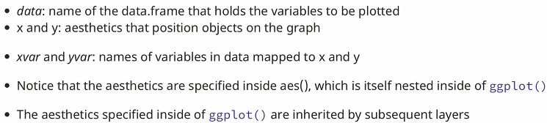

# Layers and overriding aesthetics

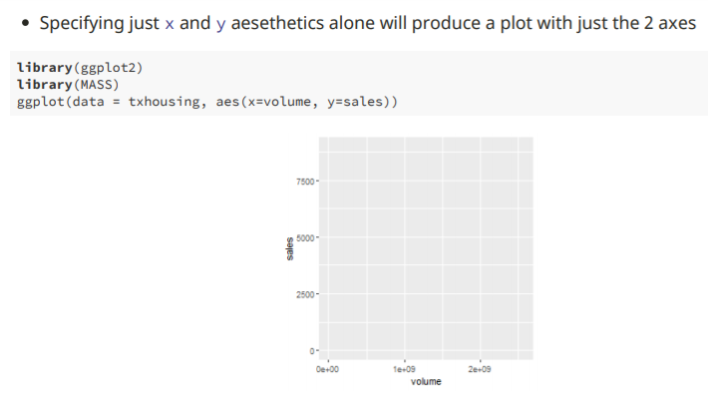

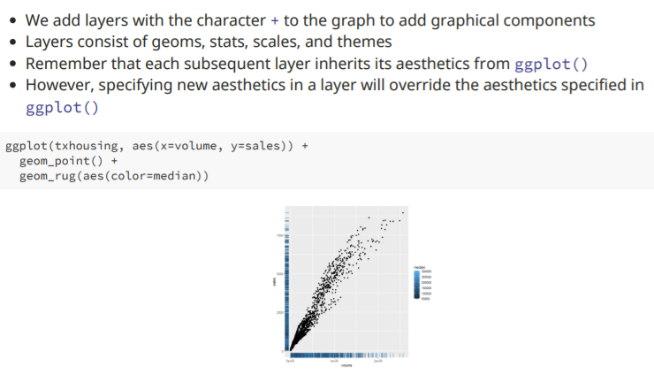

**Aesthetics**

* Visual properties of objects on graph
* Common

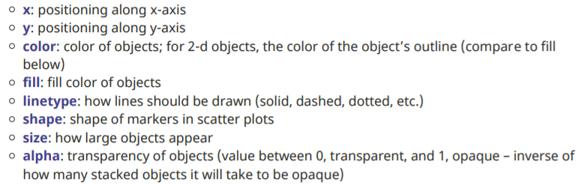

# Geoms

* Geom functions differ in the geometric shapes produced for the plot

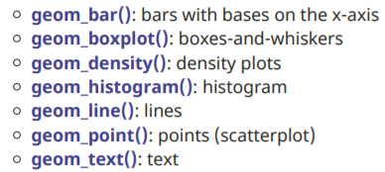

# Histograms

* Distribution of a cont. variable

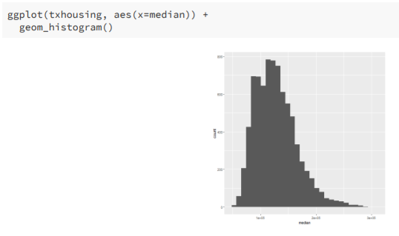

Boxplots

* Visualize stats of a distribution

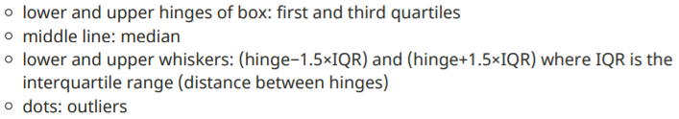

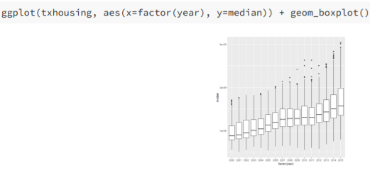

# Axis limits and titles

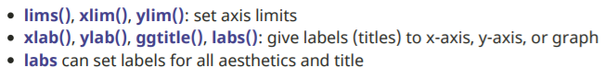

**Faceting (paneling)**

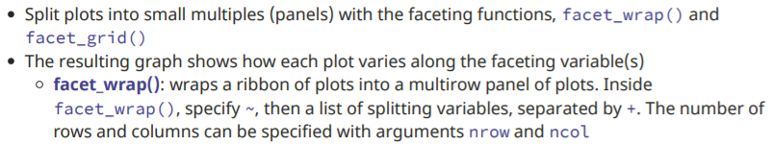

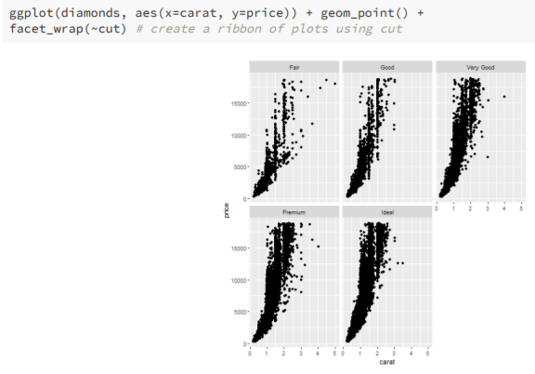

# Objectives Simulation and Program Design

* Simulations => solve real-world problems
* Pseudorandom numbers – applications in Monte Carlo simulations
* Top-down design techniques

(see slides)